**Acceptance Testing**

**UAT Execution & Report Submission**

|  |  |
| --- | --- |
| **Date** | 19 November 2022 |
| **Team ID** | PNT2022TMID05082 |
| **Project Name** | Inventory Management System For Retailers |
| **Batch No** | B11-5A1E |

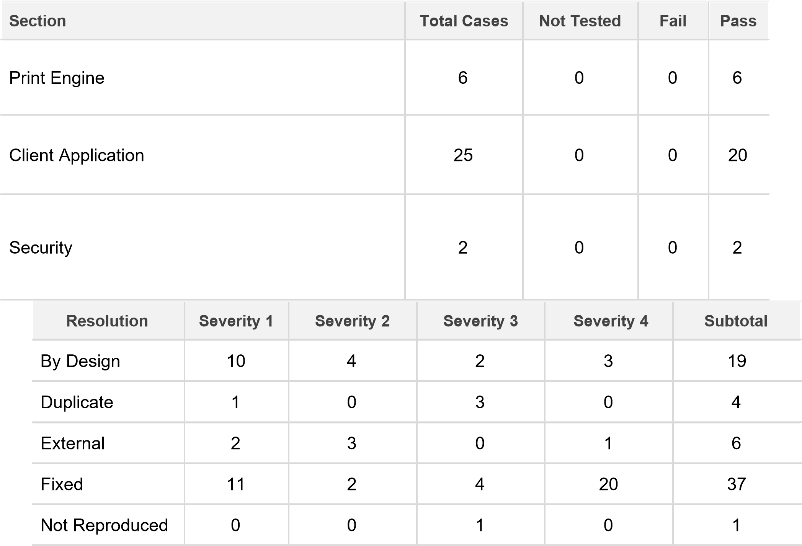

# Purpose of Document

The purpose of this document is to briefly explain the test coverage and open issues of the INVENTORY MANAGEMENT SYSTEM project at the time of the release to User Acceptance Testing (UAT).

# Defect Analysis

This report shows the number of resolved or closed bugs at each severity level, and how they were resolved

|  |  |  |  |  |  |
| --- | --- | --- | --- | --- | --- |
| Skipped | 0 | 0 | 1 | 1 | 2 |
| Won't Fix | 0 | 5 | 2 | 1 | 8 |
| Totals | 24 | 14 | 13 | 26 | 77 |

# Test Case Analysis

This report shows the number of test cases that have passed, failed, and untested

|  |  |  |  |  |
| --- | --- | --- | --- | --- |
| Outsource Shipping | 3 | 0 | 0 | 3 |
| Exception Reporting | 7 | 0 | 0 | 7 |
| Final Report Output | 4 | 0 | 0 | 4 |
| Version Control | 2 | 0 | 0 | 2 |